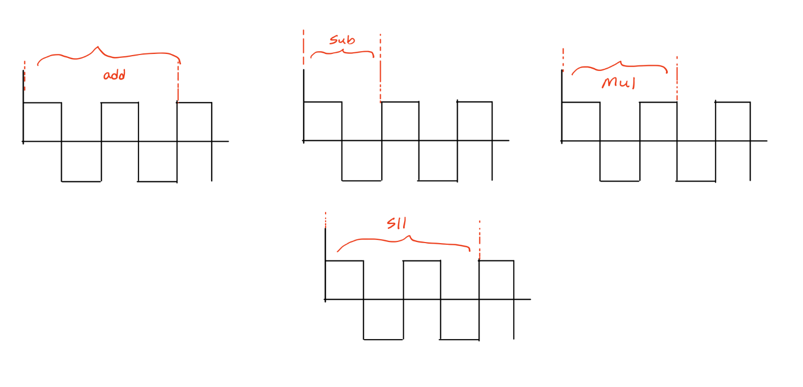

Instruction Sequence:

Add ………………

Sub ………………

Sub ………………

Mul ………………

Add ………………

Sub ………………

Mul ………………

Sll ………………..

Add ………………

Sll ………………..

Add ………………

a. Find the instruction count of the given instruction sequence.

b.

i. Find the CPI for Add instruction.

ii. Find the CPI for Sub instruction.

iii. Find the CPI for Mul instruction.

iv. Find the CPI for Sll instruction.

c. Do you need to find Average CPI here?

d. Given the clock duration is 5s; Find the CPU time of the given code sequence.

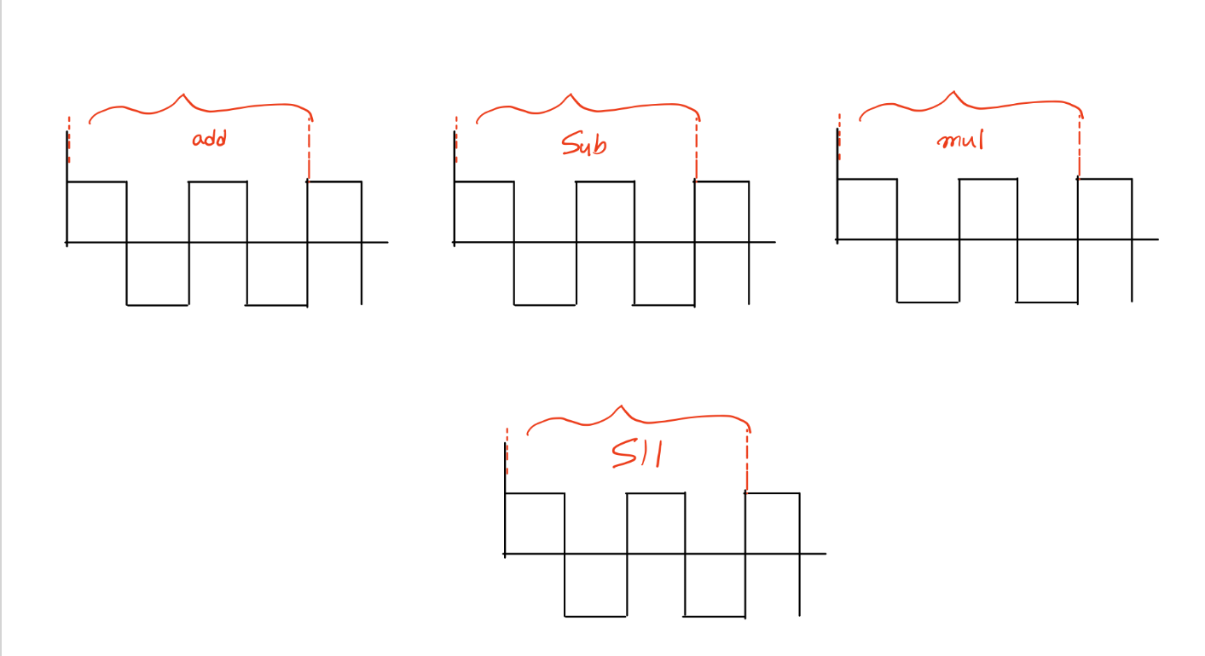

Instruction Sequence:

Add ………………

Sub ………………

Sub ………………

Mul ………………

Add ………………

Sub ………………

Mul ………………

Sll ………………..

Add ………………

Sll ………………..

Add ………………

a. Find the instruction count of the given instruction sequence.

b.

i. Find the CPI for Add instruction.

ii. Find the CPI for Sub instruction.

iii. Find the CPI for Mul instruction.

iv. Find the CPI for Sll instruction.

c. Do you need to find Average CPI here?

d. Given the clock duration is 8s; Find the CPU time of the given code sequence.

Question - 3:   
You are looking to buy a CPU and want to compare the Intel Core i5 12th Gen with the Ryzen 7 5700X. Both processors use the **Blackfin** Instruction Set Architecture.

The Intel Core i5 12th Gen has a CPI of 5.0 and a Clock Duration of 5 seconds, while the Ryzen 7 5700X has a CPI of 4.5 and a Clock Duration of 10 seconds.

Based on the given specifications choose which CPU would you choose for a better performance?